**Ridge Regression**

Ridge Regression is a type of linear regression that includes a regularization term to prevent overfitting. It's particularly useful when your dataset has many correlated independent variables (multicollinearity). By introducing a penalty to the size of the regression coefficients, Ridge Regression helps create a more robust model.

When λ increases, it shrinks the coefficients towards zero, reducing their variance and improving generalization.

**Purpose:**

Reduces Overfitting: By shrinking large coefficients, the model avoids being too specific to the training data.

Handles Multicollinearity: It stabilizes the estimates when predictors are highly correlated.

**Standardization Required:**

Features must be scaled (e.g., normalized or standardized) because the penalty term is scale-sensitive.

**When to Use Ridge Regression:**

When your linear regression model performs poorly due to overfitting.

When you have many correlated predictors and need a simpler, more interpretable model.

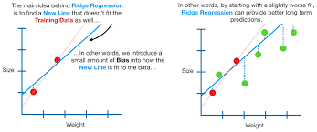

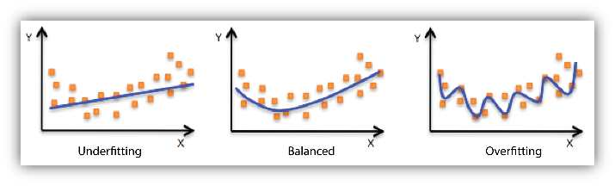

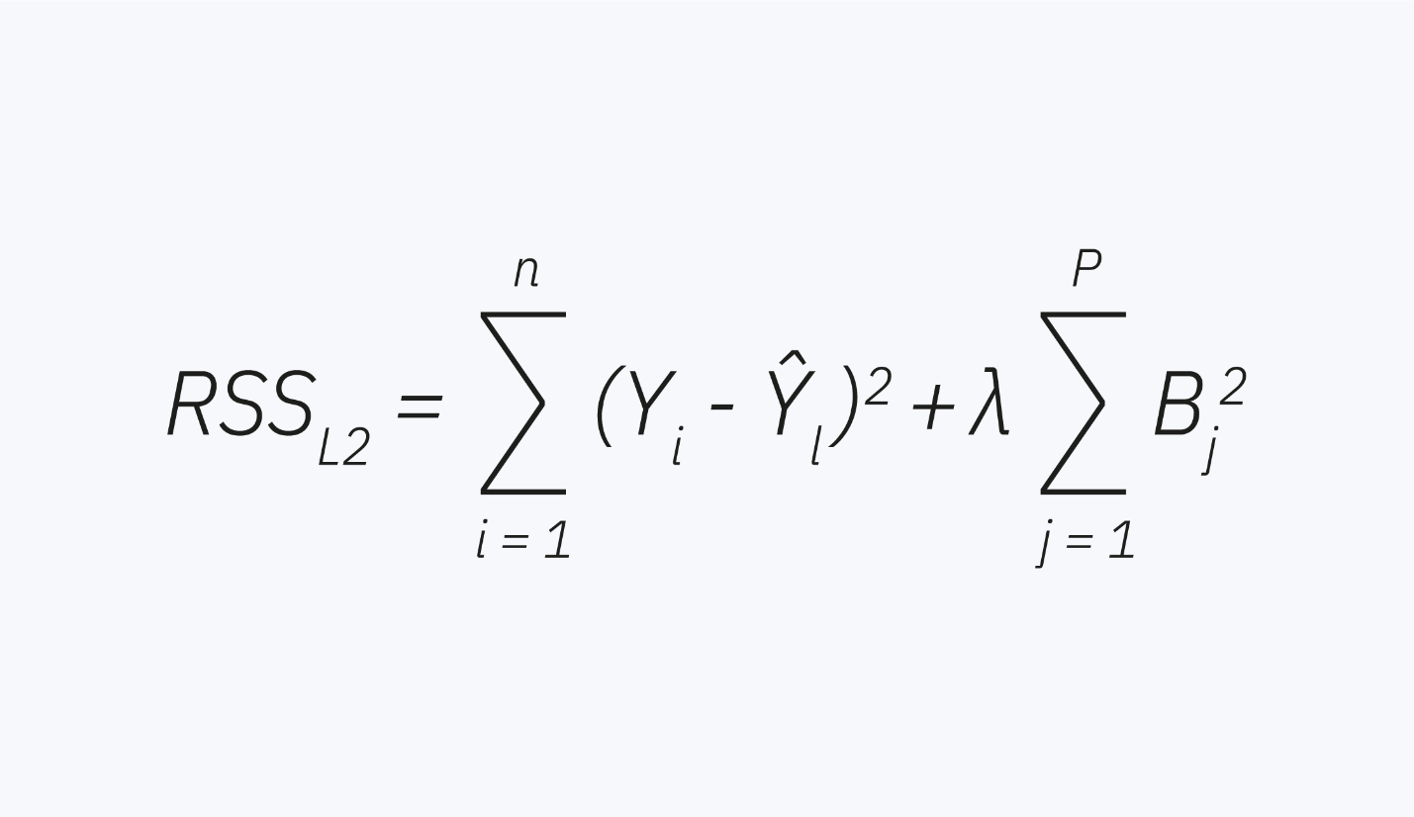

**Where:**

* J(β)J(\beta): The objective function to minimize.
* RSS\text{RSS}: Residual Sum of Squares, i.e.,
* Βj(betaj): The coefficients of the regression model.
* λLambda: Regularization parameter controlling the amount of shrinkage applied to the coefficients.
* p: The number of predictors.

**Key Points:**

* The **regularization term** (λ∑βj2\lambda \sum \beta_j^2) helps constrain the size of the coefficients, making the model less sensitive to multicollinearity and overfitting.
* Increasing λ\lambda imposes a stronger penalty, shrinking the coefficients more towards zero.
* When λ=0\lambda = 0, Ridge Regression simplifies to standard linear regression.

**ElasticNet Regression**

ElasticNet regression is a **regularized regression technique** that combines the strengths of both **Ridge Regression** (L2 regularization) and **Lasso Regression** (L1 regularization). It is particularly useful when dealing with datasets that have **high multicollinearity** (i.e., when predictor variables are highly correlated) or when you want to perform **feature selection** while maintaining some level of regularization.

**Lasso Regression**

Lasso regression, short for **Least Absolute Shrinkage and Selection Operator**, is a type of linear regression that uses **L1 regularization** to improve model performance and interpretability. It is especially useful when dealing with datasets that have many features, as it helps with **feature selection** and reduces the risk of **overfitting.**